Meshaal Mouawad
Mississippi State University, Electrical and Computer Engineering Department,
This is a summary report of my research assignments I was given by my advisor during my PhD program
Summary Report: week 8
For Research Assignments of my PhD
Summary:

- Pattern Recognition Final Project
Assignment: | Final Project Report for Pattern Recognition Course.
Completed: | Yes
Submitted: | Yes
Problems: | No
Explain: | NA
Procedure:

Assignment #2 Voronoi Diagram
Assignment: | Generate 2 Voronoi diagrams with GVD and 5 figures using MATLAB code provided for the “Voronoi Diagram project memo”.
Completed: | No
Submitted: | only one submitted
Problems: | the other map due to some errors I still get in error and I have recreated and changed the parameters but still get the same results.  different figures have been created.
Procedure: | I received two maps, Map 4, and Map 5, as it shown in Fig. 1, and Fig. 2. I created new maps using Microsoft word. And I got the results as shown in Fig. 2.2 which is not completed. I have tried to adjust the parameters but still got different path planning but all of them are not completed successfully. Some results are shown in the Appendix.

Questions: | 1. Is the problem from the map dimensions?  2. How to set up the start point and the endpoint?  3. is the resolution parameter related to this problem.

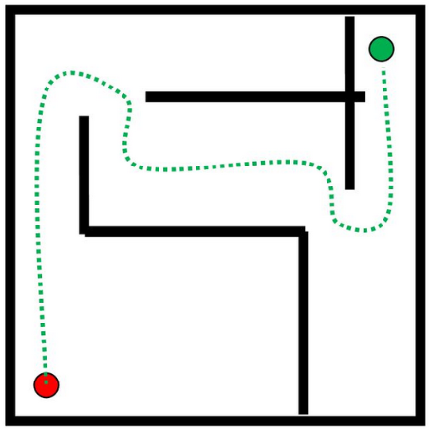
Fig. 1. Map 4, The original map.

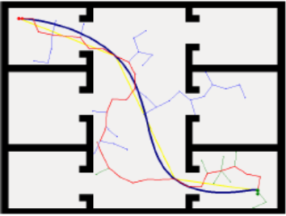
Fig. 2. Map 5, The second original map.
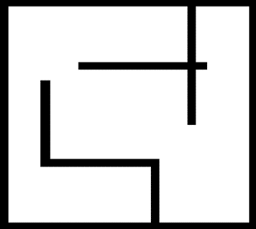
Fig. 1.1. Map 4 was created by Microsoft word.

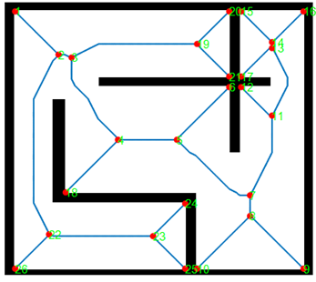
Fig. 1.2. the results of map from the MATLAB codes.

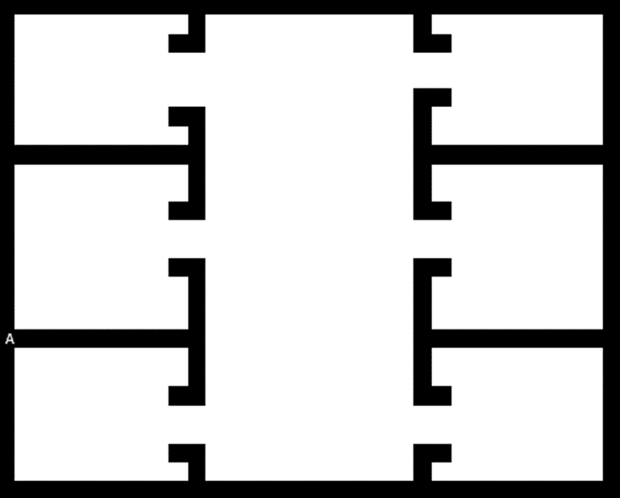
Fig. 2.1. Map 5 was created by Microsoft Word.

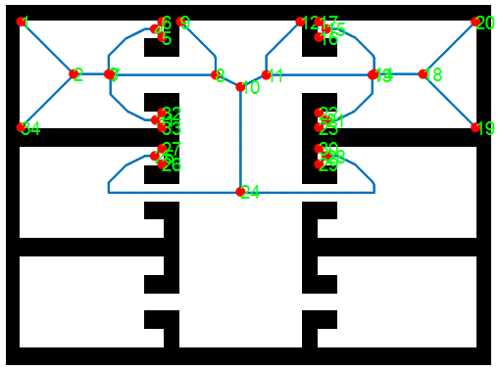
Fig. 2.2. Map 5 results from MATLAB

Reading Paper
Assignment: | Reading 2 papers
Completed: | Only one
Submitted: | Na
Problems: | Na
Explain: | Na
Procedure: | Na

Assignment: | Reading 2 papers
Completed: | Yes
Submitted: | Yes
Problems: | No
Explain: | NA
Procedure:

Appendix

File Name | Parameters  (Radius, Resolution) | Figures
Map5_15 | 1, 0.5
Map5_15 | 12, 0.5  12, 5  12, 10
Map5_15 | 11, 0.5
Map5_15 | 4, 0.5
Map5_16 | 12, 0.5
Map5_16 | 1, 0.5

This Report was submitted in 2019 for Mississippi State University, Electrical and Computer Engineering Department during Fall 2019 foe the course of Introduction to Radars Engineering instructed by Dr. Ball John Meshaal Mouawad, Mississippi State University, Starkville, MS 39759 USA (e-mail: mm4922@msstate.edu).

